BI Interview Questions
Part 1: SQL
- What is the difference between WHERE Clause and Having Clause?

- What is the difference between varchar(10) and nvarchar(10) and its impact on the SQL Server?

- Is it possible to update the Views? If yes, How, If Not, Why?

What is a correlated subquery?
- Write the general syntax for
  - adding a column to a table
  - droping a column from a table
- what is the datatype used for storing objects like PDF, Images in as Sql Server database?
- What are the errors(both functional and technical errors) in this query?

SELECT Department, Designation ,EmpCode, EmpName, MAX(salary)
FROM employee
Group by Department, Designation ,EmpCode, EmpName,salary
Having MAX(salary) < 50,000
WHERE Department in (‘Accounts’,’Sales’)

- What is the purpose of ROW_NUMBER() function? Provide with an example
- What is the Difference between Rank() and Dense_Rank() function?
- Write an update statement for converting the calmonth to Financial Month

Calender Month (input) | MonthName | Financial Month(Required Output
1 | Jan | 10
2 | Feb | 11
3 | Mar | 12
4 | Apr | 1
5 | May | 2
6 | Jun | 3
7 | Jul | 4
8 | Aug | 5
9 | Sep | 6
10 | Oct | 7
11 | Nov | 8
12 | Dec | 9

Part 2: SSIS

Define Precedence Constraint.
Precedence Constraint is used for enabling the developers to define a set of tasks logically and define the order of execution. These are connectors used for connecting all the tasks.
- Difference between Merge Transformation and Union all transformations.
Merge Transformation: This does the task of merging data from 2 sources to single output. This is useful when we need to break the data flow path to a separate error path and once the error is handled, merge that back to the main data flow. To apply this transformation, the data should be sorted first and the metadata information for the 2 paths should be the same. The sorting can be done by applying sort transformation before the merge or by providing an ORDER BY clause in the source connection.
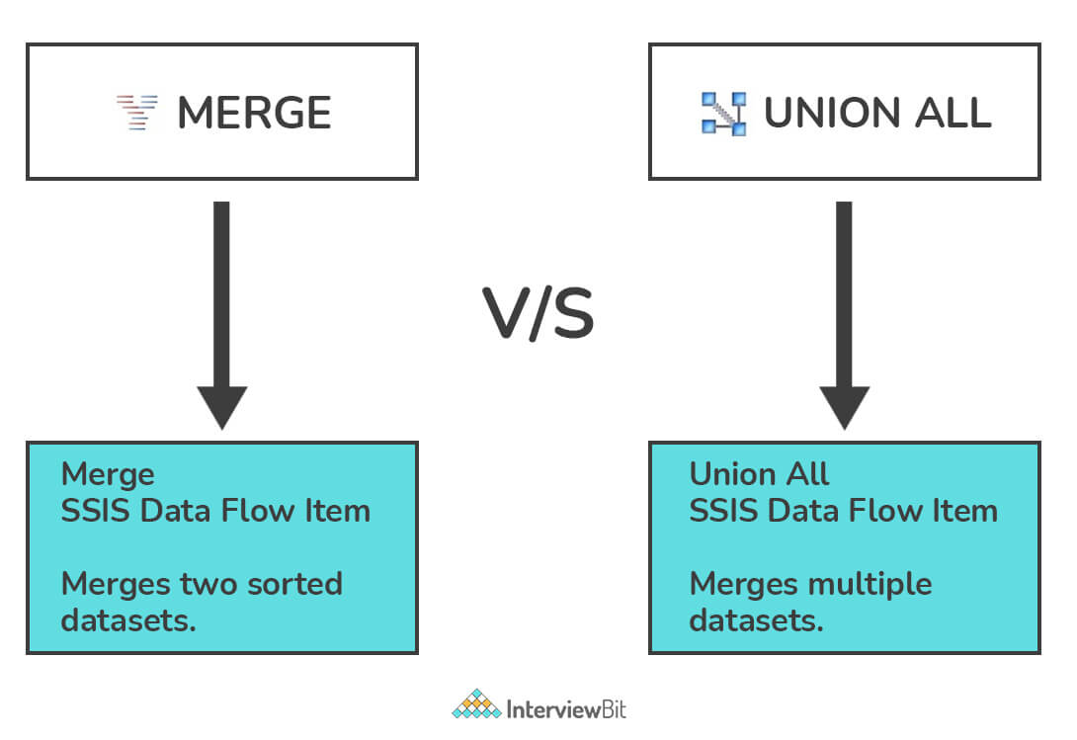
Union All Transformation: Union all transformation working is similar to merge transformation but the only difference is that this does not require sorted data. Data from different sources are transformed and combined into a single output.
- What is the difference between For Loop Container and For Each Loop Container?

How many lookup cache modes are present in SSIS?
There are 3 types of lookup cache modes. These are part of Lookup Transformation in SSIS.
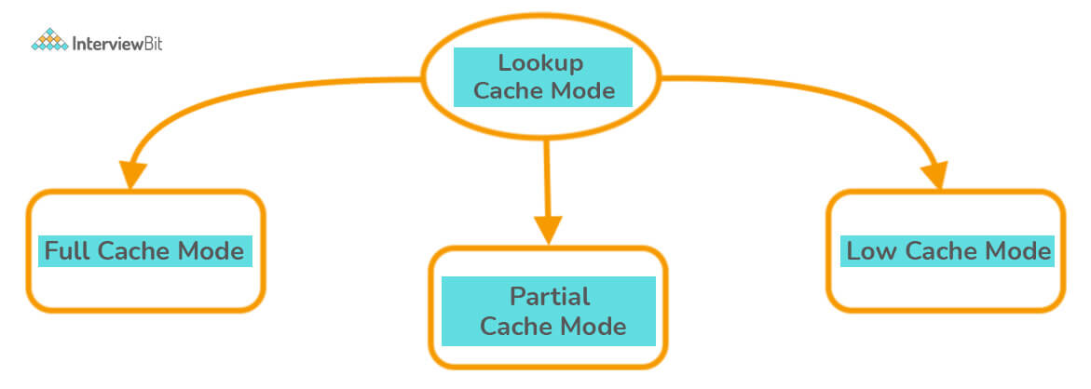
- Full Cache Mode: This mode helps in querying the database before the data-flow task is executed. This constitutes a critical part of the pre-execution step of the data-flow task. In this mode, the entire data copy is copied from the table and stored into the lookup cache in SSIS.
- Partial Cache Mode: This mode helps in querying new rows in the database from different data sources. Here, the matched row data is cached into the SSIS lookup cache. If the lookup cache is full, the data is removed automatically from the cache based on the usage statistics of the existing rows to free up space for newly matched rows.
- No Cache Mode: Here, the data is not cached unless 2 subsequent sources come up with the same matched rows. Database queries are run to get matched data every time from the source.

- What is the difference between OLEDB Source and ODBC Source? Mention its purposes.

- Name different types of Data viewers in SSIS?
Different types of data viewers in SSIS include
- Grid
- Histogram
- Scatter Plot
- Column Chart
- What is the role of the Event Handlers tab in SSIS?

On the event handlers tab, workflows can be configured to respond to package events. For instance, you can configure workflow when any task stops, fails or starts.

Part 3: SSRS

  - Name any 5 Data visualizations available in Power BI
  - what is *.rdl and *.rds represents in SSRS?
  - What is the difference between a Table and a Matrix in SSRS?
  - What is the difference between Embedded Data Source and Shared Data Source?
  - What is the purpose of a Default value and Available Value in a Report Parameter?
  - What are the data types used in a Report Parameter?
  - How to expand /Collapse the Groups in a SSRS Report?
  - Can Row groups and Column groups both be used in a Table and Matrix? Where are they used and its necessity.
  - How to perform the drill through option between a consolidated report and a Detailed Report in SSRS?
  - What is the purpose of Placeholder in SSRS?

Part 4: Power BI

  - What is the use of Drillthrough option in Power BI?

  - What is the need for Bookmarks in power BI?

  - What are the two cross filter directions in ER Modelling in Power BI? Mention its uses.

  - What is meant by Start schema and its impact in Power BI?

  - What is the difference between a Measure and Calculated Column?

  - Mention any four Quick measures available in Power BI.

  - What is decomposition Tree and its applications?

  - What is DAX Query and how it is used in Power BI?

  - What is the difference between Power Query and DAX Query?

  - What Value does the USERPRINCIPALNAME() and USERNAME() functions return?

